Dear International Officers,
The lectures of this academic year are slowly coming to an end, and we are already busy preparing for our summer school.
At the Faculty of Economics-Skopje, Ss. Cyril and Methodius University in Skopje we will organize the International Summer School which will be held in Skopje, North Macedonia.
This will be our 1st BIP International Summer School titled »AI in Action - Students and Companies Co-Creating the Future« and it will be held between the 15th and 19th of September 2025 in Skopje (on site dates), and online component in early September (preparatory) and late September (wrap-up).
You can find all information regarding the program, applications, etc. on our official webpage: https://summerschool.eccf.ukim.edu.mk
You are more than welcome to invite your students to apply to our International Summer School.
The participation of students and teachers will be supported by the Erasmus Blended Intensive Programmes (BIPs). By participating in an International Summer School, students will also receive 3 ECTS credits.
We would be delighted if you would share our invitation with your students.
IMPORTANT:
Your institution as our Erasmus partner institution:
- should insert the name of the BIP and its ID in order to register the students – participants from your Institution, the information given below
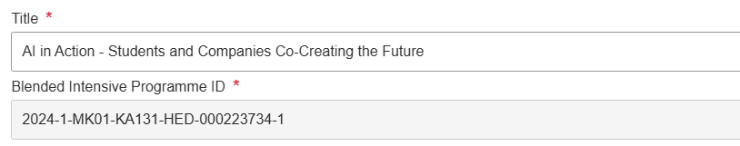
and
- Also it should insert the mobilities in the Beneficiary Modulе so that thery appear in our account in order to be recognized and valid.

If you have any question, do not hesitate to contact us at marijanasekulovska@eccf.ukim.edu.mk

With best regards,
Team of International Office
Faculty of Economics-Skopje
Ss. Cyril and Methodius University in Skopje
Skopje, North Macedonia

